**PSM10 Installation experience report**

PSM 10 - 4kW (FAL10KWh - 4 kW)

Date of completion: 2019-10-01

Assignment carried out by:

Liang Tian (esol.tech)

Customer:

**Roger Klasson**

Address:

Långsjövägen 15, 18491 Åkersberga

**Time log:**

|  |  |  |  |
| --- | --- | --- | --- |
| **Date** | **Time** | **Event** | **Note** |
| Oct 01 | **06:45** | Leaving from Uppsala | Trailer loaded the day before |
|  | **08:15** | Arriving at the site / discussion |  |
|  | **08:30** | Unloading | Cleaning up the wall for the taller than expected cabinet |
|  | **09:00** | Cabinet mounted to the wall |  |
|  | **10:00** | Coffee break |  |
|  | **10:30** | More discussion | Fixing DC-Link cable |
|  | **11:55** | All modules inserted | battery module firmware updated |
|  | **12:00** | Sorting the cables |  |
|  | **12:30** | Demo charging / discharging using PC terminal |  |
|  | **13:15** | Taking pictures / Leaving the site |  |

**Summary:**

Arrived at the customer’s house 8:15 in the Morning. The customer helped Liang to back the trailer to his front yard. After a brief talk with the him, Liang started to work.

According to the customer, he was expected to receive a smaller cabinet instead of the taller version. The cleared space he got (<2m tall) was only enough for the smaller cab.

Liang explained that the smaller cab will be available only at later time and FA should have explained to the customer what to expect. The customer accepted the fact that there is no better solution yet so he spent time to clear up another wall for the installation.

The installation manual did not arrive in advance owning to the email went to some spam folder at the customer’s computer. It was fixed on site and the customer had a printed version in hand. Liang walked the customer briefly through the installation manual.

The customer was noticed in advance that he was expected to do all the installation by himself. He understood what was needed from the manual and expressed his great interest in the idea of IKEA-furniture-like home battery system. However, he is not an installer or electrician by training. So, the work turned out not as smoothly as done by professionals. He would however like to have first-hand experience with the product before he can recommend PSM systems to his customers. The fact is he has many existing customers having FA system installed.

That said, Liang offered help for much of the installation work, including examining the junction box, part of the mounting, the cable connection etc. **It was decided on site to build a temporary PE cable, as there is no proper grounding cable prepared. Also, the DC link cable had to “fly” from the junction box to the other side of the room (photos below). The temporary PE cable was labeled with yellow tape, just for the purpose to have the system up and running before an electrician can fix everything in a proper way.**

The cabinet was mounted against a plater wall exactly the way suggested by the manual. The whole installation followed exactly what is instructed. After the switching on the system. The ESO lit up red fault LED. Liang then connected the ESO using a PC laptop to configure the system and showed the system function charging / discharging etc. The system was properly displayed from the portal before leaving the site.

Liang stopped by briefly at FA in the afternoon to discuss with Anton about the installation, who thereafter configured the system as requested. This concluded the installation of the PSM 10 system.

The next section is photos from the installation followed by the customer comment. A worth mentioning section is at the last of this report.

**Photos from the installation.**

**(with *Liang’s comment* under each photo)**

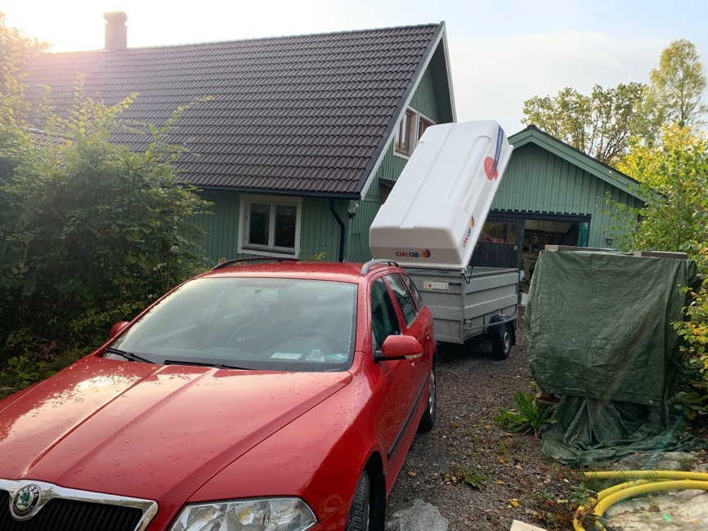

**Photo 1.** Start to unload the cargo, the battery is to be installed in the small cottage on the right. 12kW PV panel is installed on the bigger roof, on the side facing the sun (not visible from the photo). The customer has also an SMA system under his roof which works in parallel with FA system.

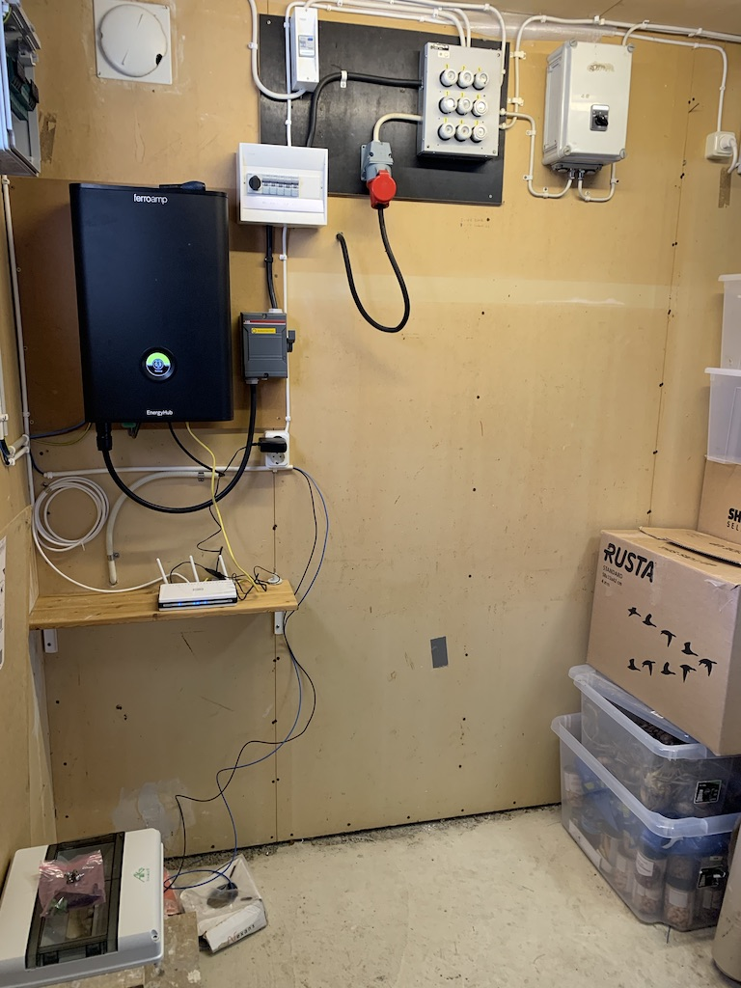

**Photo 2.** The existing EHub (14kW) has one SSO connected.

The emptied space to the right in the picture was prepared for the smaller cabinet. It turned out the space was too small for the taller one that was shipped. It was then decided to install the taller cabinet on the other side of the room.

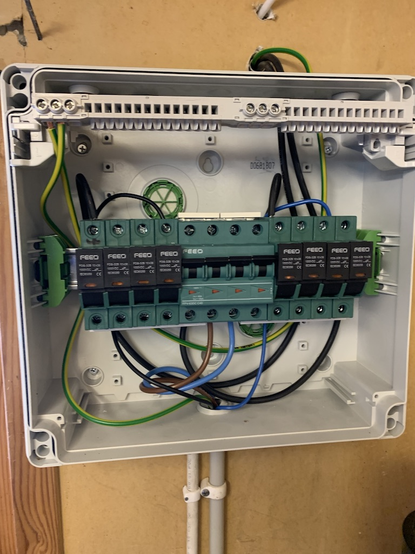

**Photo 3.** The junction box

The brown and blue cable connected to the MCB are the DC link cable. Divided by the middle line of the MCB, the left-hand side is “DC+” and the right-hand side is “DC-”.

The thinner black and blue cables are the ones prepared for the ESO. The PE cable was forgotten for which the customer has to build one so as to connect to the common PE at the junction box (the bar above the fuse holders).

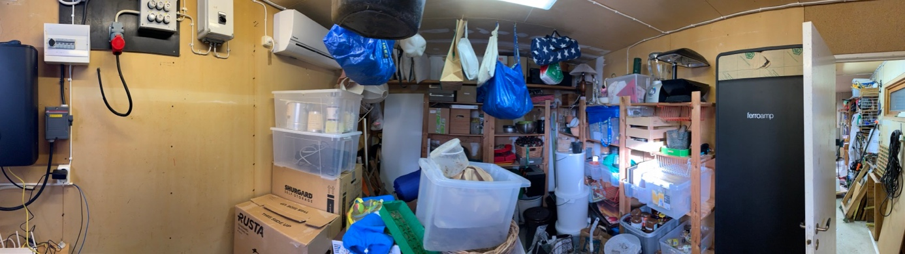

**Photo 4**. The room

A panorama photo of what inside the room. There is an air conditioner inside.

The customer said he would make sure the room temperature > 8 degree over the winter.

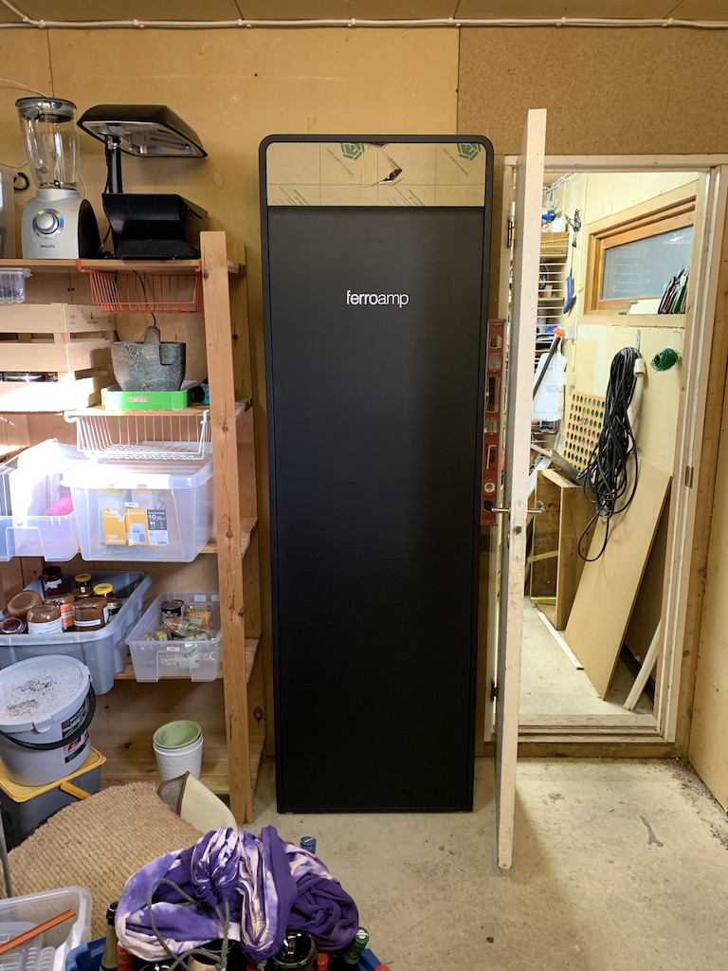

**Photo 5.** The mounted cabinet

It was only possible to mount the cabinet on the other side of the EHub instead of just next to it. The cabinet was installed exactly the way illustrated in the manual. the battery insertion was done from the righthand side.

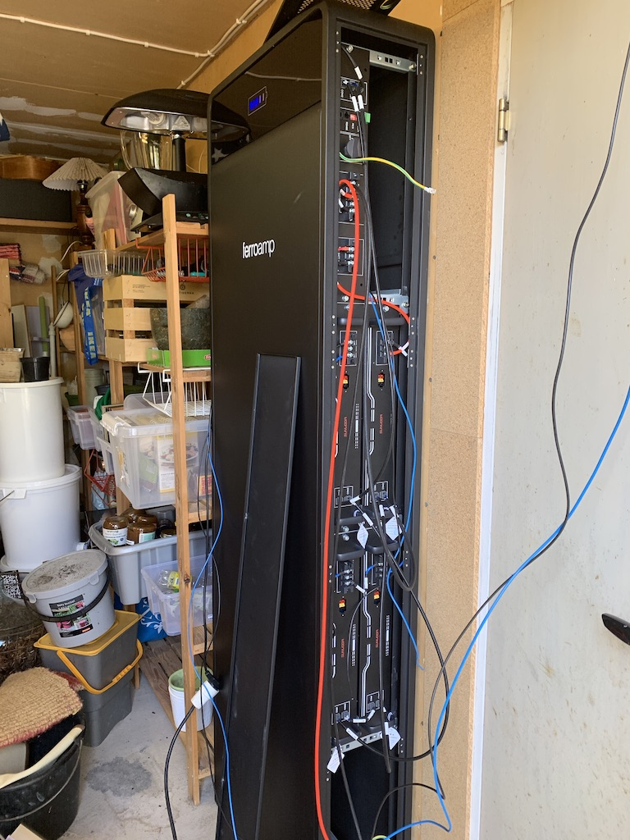

**Photo 6.** The battery installation

The 10kWh batteries were all inserted into the cabinet while the bottom two slots were left empty. In case of future upgrading, it is easy to upgrade by inserting two extra battery modules from the bottom. Moreover, in the worst case of water damage, the bottom clearance will help preventing the live battery from submerged.

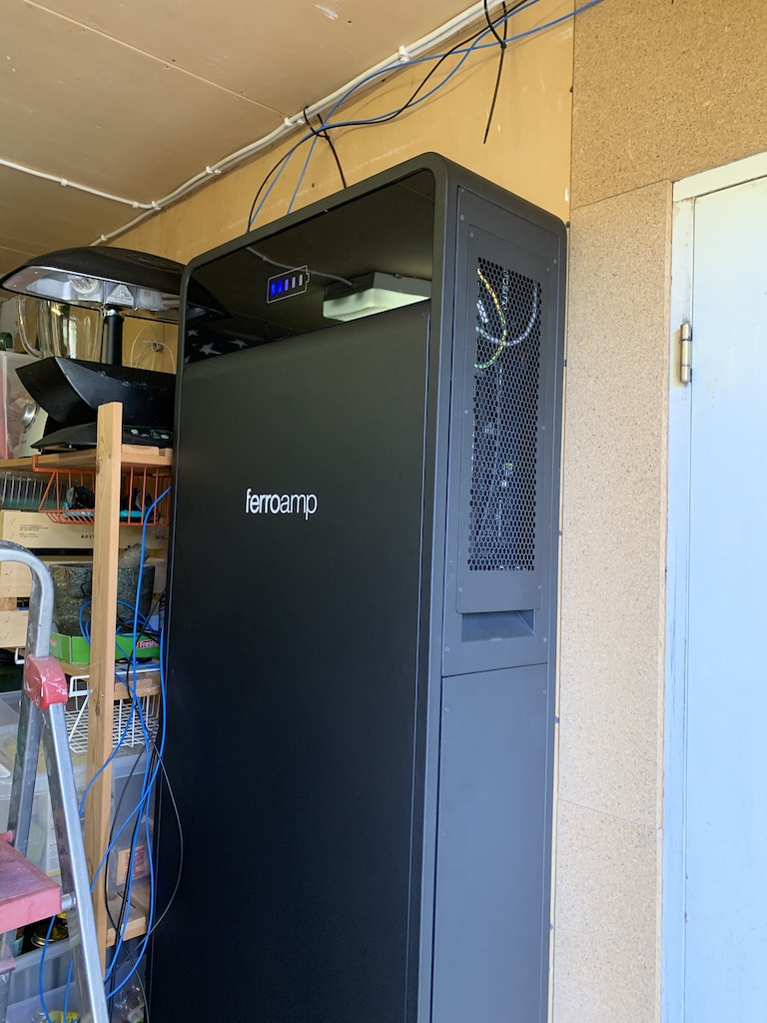

**Photo 7.** The system up and running

Liang managed to configure the system directly from the ESO.

The battery was recognized from the portal showing correct SOC and rated capacity. By the time Liang leaving the site, the system was set to topping up the battery. The customer was happy to see the system already from the mobile phone.

Liang talked with Anton later in the afternoon about the proper configuration for the customer. The delivery of the whole system was done.

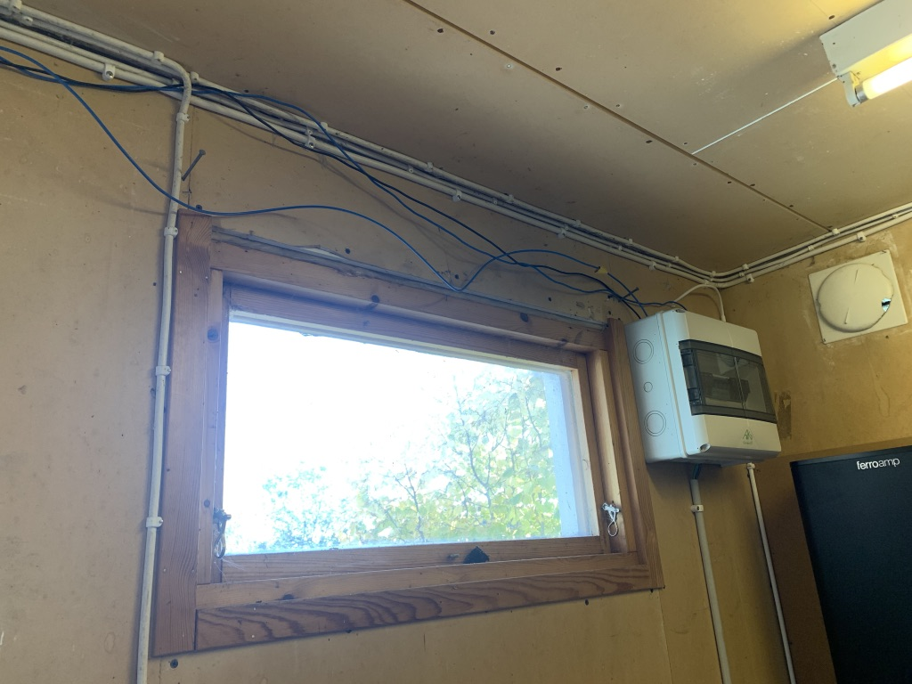

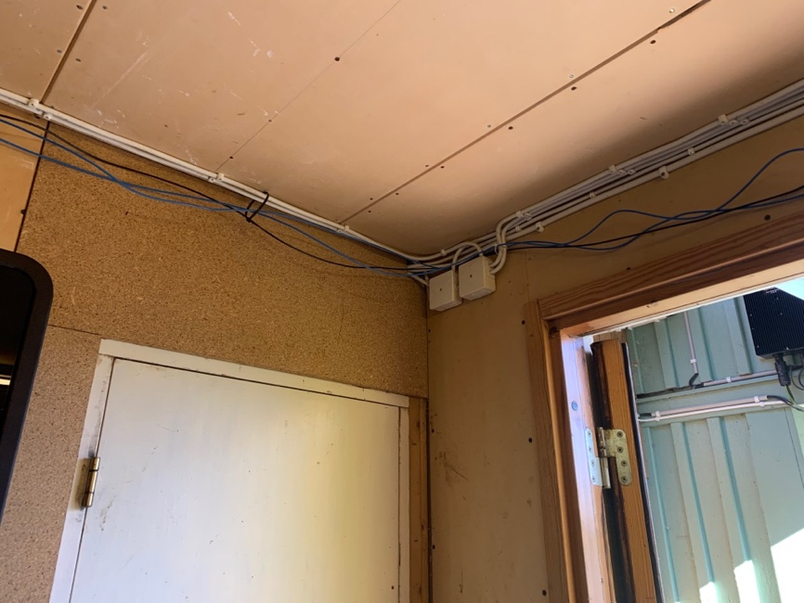

**Photo 8-9.** The fly cables

As the cabinet was installed on the opposite side of the EHub, “fly cables” were used just to make sure the system was up and running.

In the picture: Black for “DC +”, blue for “DC -”, the other blue with yellow tape is for the PE. This need to be fixed at later stage.

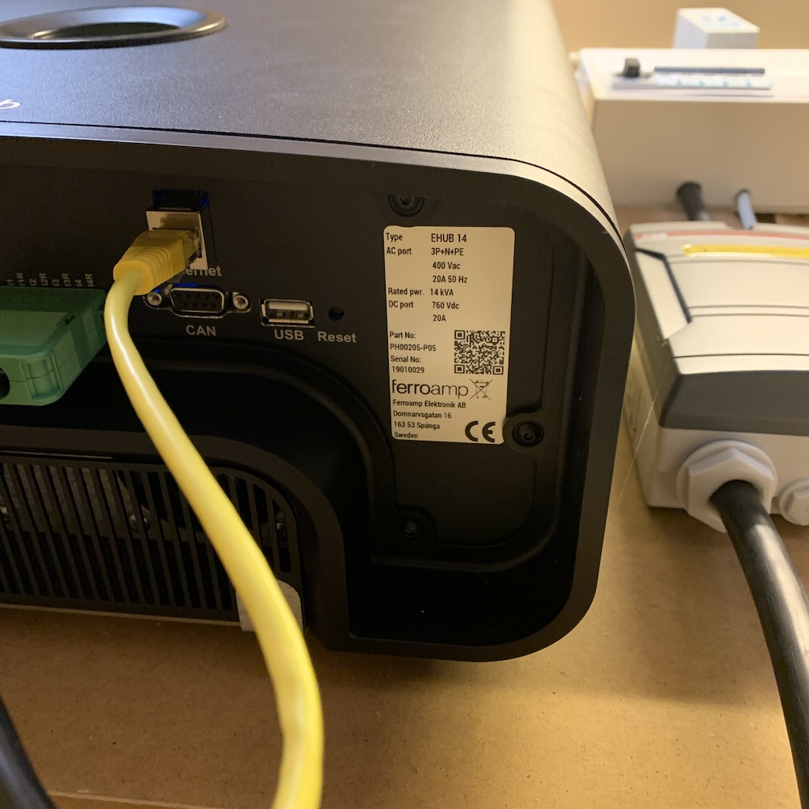

**Photo 10.** The Ehub

Liang examined the EHub which is in good working condition.

It is worth noting that when opening the MCB where SSO was connected, the LCD panel still shows number indicating PV production instead of displaying “0”.

**Customer’s comment**

1. to the installation manual

|  |  |  |
| --- | --- | --- |
|  | **Comments by customer** | **Comment by Liang** |
| 1 | The cable connection for the 10kWh system is not intuitive | (Page.18) can be improved by rewriting the text. |

2. to the generic installation

|  |  |  |
| --- | --- | --- |
|  | -- | -- |
| 2 | Should inform the customer that the taller cabinet will be shipped | I assumed the customer understand the situation since ESOL mentioned before the small cabinet will be shipped only in the future |
| 3 | ESO does not come with bolts | Noted for future delivery |
| 4 | ESO is not preconfigured | The Fault indicator on the ESO lit up (red) as soon as the system is powered on. This can cause panic since unexperienced customer is not informed on what to expect.  It is possible to include this part as a “precaution” in the PSM installation manual. It is needed however that FA and ESOL.tech agree on a meaningful way of product shipping for future delivery. |

**Worth mentioning**

**1. about the “fly” cable**

**The customer promised to call in a proper electrician to fix the cable in a proper way.**

**I suggest that FA service team to call the customer later just to make sure the fix is in place.**

2. What Liang understands from Roger’s installation:

* The existing installation consists of two PV systems: one SMA system and one FerroAmp system
* The main fuse to the grid is 20A, and the EHub clamp sensor is hooked up there
* The total installed PV (SMA + 1 SSO) = 12kW, and SMA displayed in the portal as a consumption side production (the house icon in the portal)

3. What is expected (configuration) from the FerroAmp PSM system:

* Topping up the battery during the daytime during the season with abundant sun light.
* Maintain the longevity of the battery during the cold dark season.
* Roger has a KIA e-Niro (64 kWh) at his house, a regular AC wall charger. He would like to charge the car over the night. It will be good to be able to shift the PV production from daytime to nighttime to meet the need for the car charging. The exact setting would be based on the real household consumption as he has only 20A fuse.

3. Liang’s generic impression for the installation:

* The customer is not a professional electrician / installer by training.
* The junction box was said built by professional, Liang recon that it is in acceptable quality but there is no label
* FEEO brand MCB / fuse holders were installed at the customer site.
  + By the time of the installation, the fuses were prepared. Liang assumed the fuse size were correctly selected. No examination was done at the site.
* The DC-link cable is said sized at 2.5mm. However, the cable work was done in a way just to showcase the system functioning. **Additional work is needed.**
* The customer will ask professional electrician to fix the cables.

4. Additional comment for the ESO preparation / packaging:

* Liang picked up ESO directly from the production that was pre-assembled with the adaptor and the front plate
* The pre-assembled ESO is difficult to transport; Liang has found a walkaround:

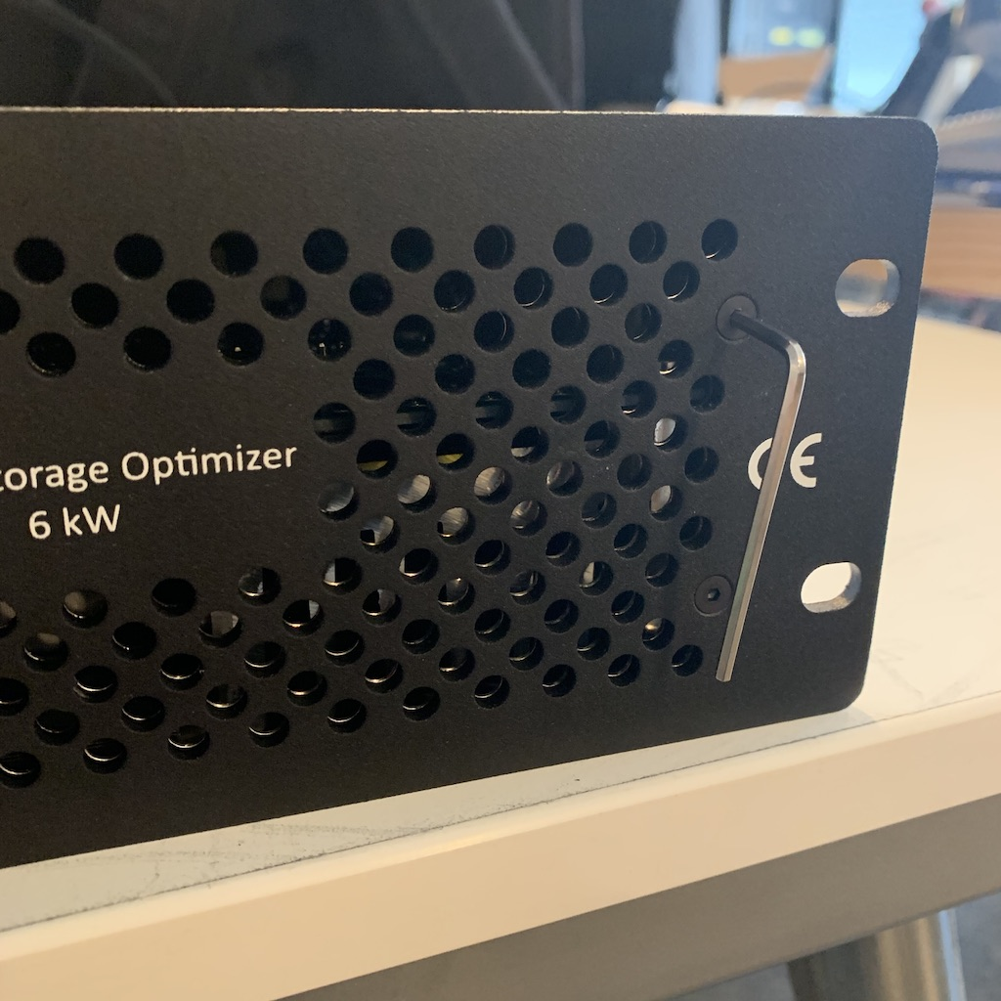

**Photo 11.** The ESO with front plate

An ideal way for ESO transportation is to ship it with the front plate removed. However, Liang found it not possible to untighten the screw as it was so firmly fastened.

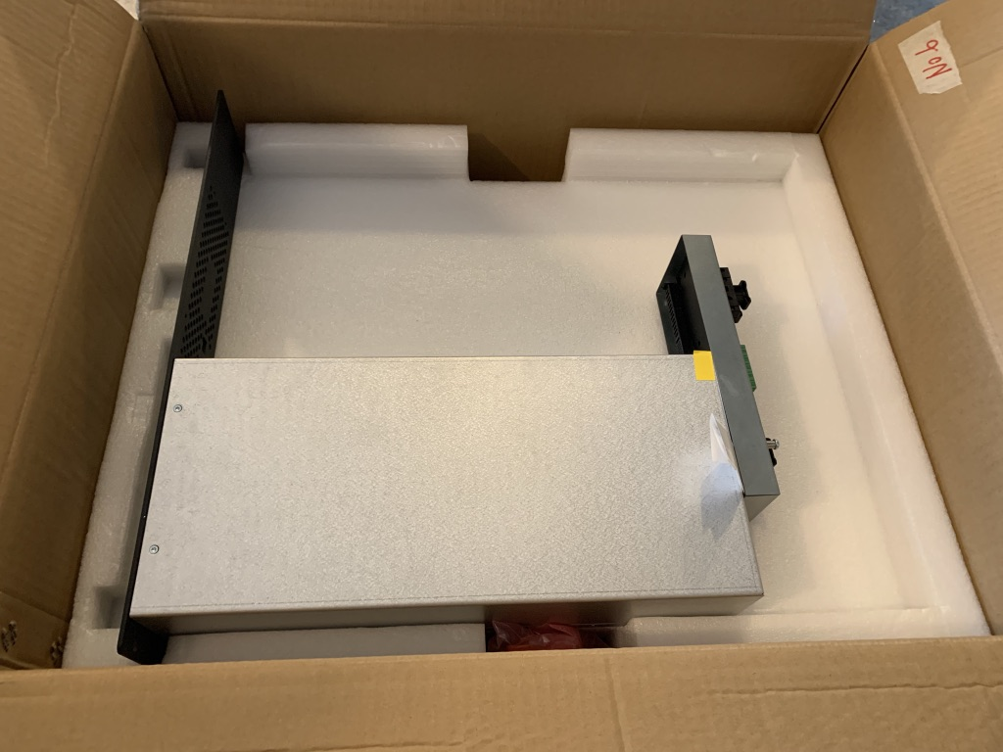

**Photo 12.** Temporary fix for ESO shipping package

Note that when shipping with only one ESO, the whole assembly is not as sturdy compared to Duo-ESO configuration thus must be handled with care. It is not allowed to lift the assembly by holding only the ESO adopter (only two screws are used between the two).

One SU canton box (the box used for the sample rack at FA showroom) was used to ship the preassembled ESO. The whole assembly fits nicely into the pre-cut protective foam made for the SU battery module.

There can be better packaging solution presumably done by FA.

**(This is the end of the report.)**